**A Dissertation Report on**

**Traffic Management System**

**Name of student: Roshan Giri**

**UN ID: 18406492**

**BSc Computing (Software Engineering)**

**Supervisor: Nishant Neupane**

**NAMI College**

**University of Northampton**

**Jorpati, Kathmandu, Nepal**

**Demo Link:**

<https://northampton.mediaspace.kaltura.com/media/Dissertation_Demo_18406492/0_tds2tfax>

1. Table of Contents

1 Introduction 6

1.1 Background or Literature Review 6

1.2 Project aim and objectives 7

2 Project Development Methodology 7

2.1 Problem Domain 7

2.2 System specification Phase 8

2.3 System Design and Testing Phase 8

3 Requirement Engineering 8

3.1 Elicitation Activities 8

3.2 Other problem domain research 9

3.2.1 Comparable Software System Review 9

3.2.2 Development Relevant Legislation 11

4 Requirements Specification 12

4.1 Problem Domain Description 12

4.2 Existing Traffic Management System 12

4.3 Summary of the existing Traffic management System And limitations 13

4.4 Functional Requirements 13

4.4.1 Functionality Color Definition 15

4.5 Performance Requirements 18

4.5.1 Speed 18

4.5.2 Capacity 18

4.5.3 Reliability 18

4.5.4 Usability 19

4.5.5 Security 19

4.6 Acceptance Tests 19

4.7 Commercial Constraints 20

5 System Analysis and Design 21

5.1 Preliminary Design Stages 21

5.1.1 Textual Analysis 21

5.1.2 Significant Event Analysis 22

5.2 Activity UML Diagram 23

5.3 Use Case Diagram 24

5.4 Sequence Diagram 25

5.5 System Class Diagram 27

5.6 Entity Relationship Diagram (ERD) 28

6 System Interface Design 30

6.1 Draft Interface Designs 30

6.2 Wireframes 30

6.3 System Screen Mock-ups 33

6.4 Heuristic Evaluation 35

7 System Build and Technical Notes 37

7.1 System Build Environment 37

7.2 Code and Folder Structure 37

7.3 Features and Functionality Implementation 38

7.4 On-going Testing Methodology 48

8 Test Strategy 49

8.1 Overview of Test Strategy 49

8.2 Sample Test Results 49

9 System Evaluation 54

9.1 Usability Evaluation 54

10 Project Conclusion 55

11 Reference 56

12 Appendix 57

12.1 Project Plan Gantt Chart 57

12.2 Presentation - PowerPoint Slides 57

12.3 Final Interface Design 68

12.4 Supervisor Log 73

**List of Tables**

Table 4. 1: Functionality Description 13

Table 4. 2: Functionality Color Definition 13

Table 4. 3: Administrator, traffic police, and User level permission 13

Table 4. 4: Traffic Police Record 14

Table 4. 5: Route Record 14

Table 4. 6: Traffic Record 15

Table 4. 7: Diversion Record 15

Table 4. 8: User Record 15

Table 4. 9: Emergency Information Record 16

Table 4. 10: Software Acceptance Test 18

Table 4. 11: Commercial Constraints 19

Table 5. 1: Textual Analysis 20

Table 5. 2: Significant Event Analysis 20

Table 6. 1: Heuristic Evaluation 34

Table 7. 1: Software Build Environment 35

Table 8. 1: Black Box Testing 51

**List of Figures**

Figure 3. 1: System Architecture of IRIS 7

Figure 5. 1: Traffic Management System Activity Diagram 21

Figure 5. 2: Login Activity Diagram 22

Figure 5. 3: Use Case Diagram of the System 22

Figure 5. 4: Login Sequence Diagram 24

Figure 5. 5: Sequence Diagram of the System 24

Figure 5. 6: Class Diagram of the System 25

Figure 5. 7: ER-Diagram of the System 27

Figure 6. 1: Login portal of the system 28

Figure 6. 2: Admin Wireframe 28

Figure 6. 3: Wireframe of User registration form 29

Figure 6. 4: Wireframe of emergency request form 29

Figure 6. 5: Wireframe of System User Viewing live traffic conditions 30

Figure 6. 6: Login Mock-up 31

Figure 6. 7: Admin Mockup 31

Figure 6. 8: System User Mockup 32

Figure 6. 9: User Registration Mockup 32

Figure 6. 10: User Mockup 33

Figure 7. 1: Folder Structure 36

Figure 7. 2: Login Implementation 37

Figure 7. 3: Check Username and Password 38

Figure 7. 4: User Signup and Add Data into file system 38

Figure 7. 5: Add Traffic Police Information 39

Figure 7. 6: Display Traffic Police Information 39

Figure 7. 7: Table Columns to display Information of traffic, routes, diversions, request and user information 40

Figure 7. 8: Edit Traffic Information 41

Figure 7. 9: Delete Traffic Information 41

Figure 7. 10: Add Route Information 42

Figure 7. 11: Display Route Information 42

Figure 7. 12: Edit Route Information 43

Figure 7. 13: Remove route information 43

Figure 7. 14: Add Diversion Information 44

Figure 7. 15: Display Diversion Information 44

Figure 7. 16: Edit Diversion Information 44

Figure 7. 17: Delete Diversion Information 45

Figure 7. 18: Adding Emergency Request 45

Figure 7. 19: Displaying Emergency Request in Administration area 46

Figure 7. 20: Displaying Users Information in Admin area 46

Figure 7. 21: Testing Flow Diagram 47

**Dissertation Demo Video Link:**

<https://northampton.mediaspace.kaltura.com/media/Dissertation_Demo_18406492/0_tds2tfax>

# Introduction

Traffic congestion is one of the serious problems faced by the Nepalese people in their day to day life. There are very few traffic lights in the streets of Kathmandu city which results in the huge traffic jams. Most of the streets of Kathmandu are monitored by a traffic police. If a traffic police is absent in the streets than it would cause a lot of traffic jam especially during the rush hours. According to an article which was published in 2018, the number of vehicles has exceeded 1.1 million in Kathmandu which results in more problem for traffic management. (The Himalayan Times, 2019).

Due to our geographical location and unmanaged urbanization the people of Kathmandu are facing a serious problem. They are losing a lot of time in the traffic. If we are able to solve this problem than they can utilize this time in doing something resourceful. There are other major problems that causes huge traffic jams such as not obeying rules, holes and ditches in road, unwanted parking, not dividing the lanes properly and so many more. One of the serious concerns of the unmanaged traffic management is sick people are dying, because they are not able to get to hospitals on proper time for their treatment. People from other districts come to Kathmandu for better treatment and due to traffic jams, they are not reaching the hospitals, which raises concern for their health. Recently a patient dies as ambulance gets stuck in traffic for hour and hour. (The Himalayan Times, 2019)

## Background or Literature Review

Literature review has secured looking, gathering and breaking down from all discussion’s issues in order to find the best possible method for traffic management. The reality and finding are being broke down by recognizing the goals, the present circumstance and the resources that are available. The background and literature review help to know about the ideas, concepts, introduction, works that are already done, drawbacks and advantages of the previous work or existing system. Many researchers have tried numbers of ways to find the best possible method for solving the traffic related problems.

The author studied the paper (Jongwan Kim, 1997) that uses fuzzy logic controller for the traffic management system. In the old generation the traffic signal basically works on the allocated time for each and every signal. Even though the traffic is highly congested in one road while on the other side the traffic is free the system works on the allocated time services in the old generation traffic signal. But in this paper, the author found that the traffic controllers use fuzzy logic controller. The fuzzy logic controller is controlled according to the traffic volumes in road. In this researched paper the author found that the controller used different variables to calculate the traffic congestion such as arrival of vehicles in a place, queue of a vehicle in a place and all together the traffic volume. In this paper the controller is only used in a single intersection. The testing of this controller was done in a simulation and shows the best results for controlling the traffic congestion in a single intersection.

This fuzzy logic controller used in a single intersection provided better results in simulation which helps to solve the traffic congestion, allocate traffic signal time on the basis of traffic volume and so on. The main disadvantage that the author has observed in this paper is that the traffic controller is only used in an intersection but not in a junction. (Jongwan Kim, 1997).

The author also researched on different advanced traffic management systems such as IRIS, Georgia Navigator and KITS (Kimley-Horn Integrated Transportation System). All of this application is an advanced traffic management system which uses live video surveillance to track and monitor the vehicles. This advanced system solves the problem related to traffic such as traffic congestion, road incidents, assistance to emergency services and so on.

## Project aim and objectives

The main purpose of this project is to solve the traffic related problems such as huge traffic congestion, save time, provide best traffic free route to emergency services, make traffic diversions, find best possible routes for emergency services, aid traffic police officers and citizens.

Aim

1. The main aim of this project is to build a very reliable traffic management system that will help to solve the traffic congestion. Emergency Services will be provided guidance by the management team to reach the destination without facing any traffic problems.

The management system will be a java base GUI application which will be monitored by the traffic management team and accessible by the traffic police and other users.

Objectives

1. Evaluate the current problem the people are facing
2. Research on any previous software solutions if exists
3. Research if there is any equivalent system and tools to develop the management system
4. Research and Investigate the functional requirements of the traffic management system
5. Research the technology needed to develop the system
6. Performance requirements of the traffic management system
7. System design and architecture of the traffic management system
8. Choose best testing and evaluation strategy for the management system

# Project Development Methodology

## Problem Domain

Current traffic management is done by the traffic police. To complete this project the author has to investigate on the traffic related areas. Mainly in the developed country more advanced traffic management system has been implement. There are traffic control centers to monitor the traffic condition through live feed of the road. A sensor is placed in the road so that the sensor counts the number of vehicles in the road and send the signal to the management team so that they can open the traffic. But in our country even a traffic lights are not implemented and there are no services for emergency vehicles such as ambulances, firefighters and so on.

Study and research were conducted in different parts of the Kathmandu city; the traffic management was mostly done by the traffic police. There were very few unintelligent traffic lights. People have to wait hour and hour for the traffic to clear. Due to the geographical location, unmanaged urbanization, congested road people are facing a serious problem. They lose hours of their time in traffic that can be utilize to do some resourceful works. The roads of the Kathmandu city have holes, unwanted parking’s, unguided lanes to keep the vehicles in the proper lane. The road management is very bad. Due to the difficulties faced by the Nepalese people the problem should be solved by developing a new traffic management system.

The huge traffic jam raises more concern for ambulances. Many people die due to late arrival at the hospital. If the traffic problem can be solved we would be able to save thousands of lives.

Suppose, if a patient is arriving in ambulance and they send the travel route to the traffic management team or traffic officer than they would not have to face the traffic problems. The management team or traffic police would be able to provide guidance to the ambulance service.

## System specification Phase

After analyzing the problems faced by the people, a good JAVA based GUI application will be designed to solve the problems. In this application the main users will be admin, system user, traffic police and people. The can access their account via a login portal. The admin can view traffic and solve the traffic congestion by controlling the traffic signals. System user and traffic would be able to access the functionality. The main function is to manage traffic, manage traffic police, mange emergency request, manage diversion and manage route.

## System Design and Testing Phase

After the intense background research on current existing traffic management system and advance traffic management system the system designing process was done. System wireframes and system mock-ups were made in order to visualize the system that is to be made to solve the problems of traffic management. User-friendly and attractive design of wireframes were made. Appropriate font sizes and colors were used while designing the mock-ups of the system. After the creation of wireframe and mock-up testing was done.

# Requirement Engineering

The vehicles data will be collected from the transport and management organizations so that we would know the total number of vehicles that are registered in the Kathmandu valley. Maps of road will be collected and possible installation of traffic lights areas will be inspected in order to solve the problem.

## Elicitation Activities

Elicitation concerns gathering information from different sources such as journals, conference papers, articles and so on. The elicitation activity is very important because the requirements are gathered through this process.

After gathering the appropriate information, we have to analyze the collected information and understand the problem and problem domain of the system. The understanding of the problem should be prepared by making a requirement documentation.

## Other problem domain research

The problem domain research consists of comparable software system review and development relevant legislation. The legislation is a very important factor while developing a software system. We should consider legal issues that may rise ahead while the software is completed. Comparable system helps us to understand the merits and demerits of that system and help us to add features that we like in those systems.

### Comparable Software System Review

1. **IRIS (Intelligent Roadway Information System)**

IRIS is an advanced traffic management system. This system is used for the transportation agencies to manage the traffic monitoring and controlling the devices. The programming language used for the development of the Intelligent Roadway Information System was written in JAVA language.

This advanced traffic management system is presented through an intuitive map-based interface to system operators.

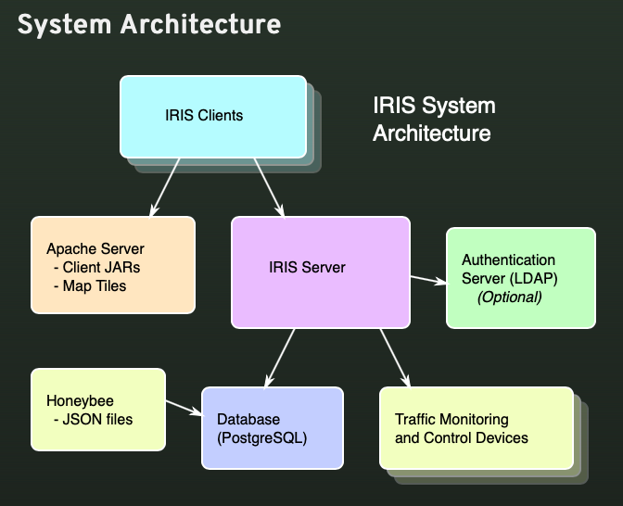

Figure 3. 1: System Architecture of IRIS

**Merits of an Intelligent Roadway Information System (IRIS)**

1. The system has a client and server architecture
2. The traffic data and system data are stored in PostgreSQL database which is managed by the IRIS server
3. The system handles communication with all traffic control and data collection devices
4. The IRIS management system is operated by an apache web server, using Java Web
5. The IRIS system is highly secured as the communication between the people using the app and the serve is encrypted
6. If any accident or incident occurs in the roads than the management teams are alerted through the system
7. The system monitors the speed of a vehicles and control the speed
8. The IRIS software can perform active traffic management and lane control
9. Detects congestion
10. Warns vehicles about danger such as bad weather conditions
11. This system software provides a ramp meter to help control the congestion of traffic in highways.
12. Live feed of traffic through cameras
13. **Georgia Navigator**

The Georgia Navigator is also an advanced traffic management system which is used to regulate traffic in the Atlanta city and different others areas in the state of Georgia. This traffic management system accumulates traffic data with use of traffic sensors, traffic cameras and ramp meters. This system distributes its messages signs of traffic insights.

**Merits of Georgia Navigator**

1. Regulates traffic through the traffic cameras.
2. Uses ramp meters and a traffic speed sensor to extract traffic data.
3. Traffic Insights are distributing through dynamic message signs
4. **KITS (Kimley-Horn Integrated Transportation System)**

The other comparable ATMS (Advanced Traffic Management System) is KITS. The Kimley- Horn Integrated Transportation System is an advanced traffic management system which manage the priority of transit options and manages the congestion of traffic. This system uses the live CCTV footage in order for monitoring the traffic. Through this monitoring system this system detects problems and send alerts to all the relevant people of the management system.

**Merits of KITS (Kimley-Horn Integrated Transportation System)**

1. Manage priority transit options to manage congestion
2. Use of live CCTV footage for traffic monitoring
3. Alerts relevant personnel if problem occurs in roads by the help of monitoring system
4. This system provides one interface which controls all Integrated Transportation Systems devices and applications and can also be accessed from personal computers or mobile devices

### Development Relevant Legislation

Ethical and legal considerations should be addressed before we move to make a project.

There are certain laws and acts that we should abide to make sure that no problem occurs later in the development process of the project. Some of the ethical and legal considerations are addressed below:

1. The Privacy Act, 2075(2018)

The right to privacy and protection of information is a fundamental right of all the people. This act was introduced with the purpose of giving constitutional right to the people. The privacy act states that:

“Whereas, it is expedient to make legal provisions on promoting dignified living standards by making provisions to ensure the right to privacy of the matters relating to body, residence, property, document, data, correspondence and character of every person, to manage the protection and safe use of personal information remained in any public body or institution, and to prevent encroachment on the privacy of every person; Now, therefore be it enacted by the Federal Parliament.” (NLC, 2019)

The Privacy Act ensure that the right to privacy of documents, communication, data, body, property and character of person remains confidential.

1. Motor Vehicles and Transport Management Act, 2049 (1993)

This is an act that is made to provide for motor vehicle and transport management. The Motor Vehicles and Transport Management Act states that:

“Whereas, it is expedient to make transportation services consolidated, efficient and effective with a view to preventing motor vehicle accidents, enabling the victims of accidents to have compensation, providing for insurance and making transportation facilities available to the public generally in a simple and easily accessible manner; Be it enacted by the Parliament in the twenty first year of the reign of His Majesty King Birendra Bir Bikram Shah Dev.” (Lawcommission.gov.np, 2019)

This act ensures that the people get the transportation services easily and in case of accidents the victims would be compensated.

1. Motor Vehicle Tax Act, 2031 (1974)

The Motor Vehicle Tax Act states that:

“Whereas, it is expedient to manage modus operandi of levying and recovering of motor vehicle tax leviable under the prevailing Nepal law; Now, therefore, be it enacted by His Majesty King Birendra Bir Bikram Shah Dev, on the advice and with the consent of Rastriya Panchayat.” (Lawcommission.gov.np, 2019)

1. The Act Relating to Rights of Persons with Disabilities, 2074 (2017)

This act states that:

“Whereas, it is expedient to amend and consolidate laws relating to rights of persons with disabilities in order to respect their civil, political, economic, social and cultural rights by doing away with discrimination against persons with disabilities and to ensure the environment that enables persons with disabilities to earn self-reliant and respectful living by empowering persons with disabilities and getting them to have participation in the process of policy making, and development; Now, therefore, be it enacted by the Legislature-Parliament pursuant to clause (1) of Article 296 of the Constitution of Nepal.” (NLC, 2019)

This act empowers the people with disabilities by participating them in the process of policy making and development.

# Requirements Specification

The requirements of the Traffic Management System should be met in this section. The limitations that exists in the previous system should be solved by the traffic management system application. All the information that was collected from the elicitation activities is useful in the requirement specification phase. This section consists problem domain description, existing traffic management system, merits and limitations of the previous traffic management system, functional requirements of the new traffic management system that is to be developed and, performance requirements of the system.

## Problem Domain Description

The current traffic management system is totally based on traffic police. Only in few places there is implementation of unintelligent traffic lights. All of the traffic related problems are solved by the traffic police without any help of the management team.

## Existing Traffic Management System

The inductive loop detection method has not been implemented in the traffic management system of our country. The traffic system runs with very few unintelligent traffic lights and with the help of police officers. Due to the poor existing traffic management system there is more problems related to traffic such as traffic congestion, traffic accidents, rule breaking and so on. Many emergency services have to face the traffic in emergency services.

## Summary of the existing Traffic management System And limitations

The unintelligent traffic lights signals are one of the oldest methods for managing the traffic conditions. Many new technologies have been introduced but has not yet been implemented in our country. Due to unmanaged urbanization and very poor traffic management system the day to day life of the people is affected. Thousands of vehicles are added every month which results in more traffic congestion. It is very hard for the police officer to manage traffic without the help of the traffic control room. Emergency services such as ambulances, fire fighters are also affected by the poor management system. In a calendar year, thousands of Nepalese People loss their life due to traffic.

There are many limitations in the existing system. The system is not reliable and effective. The system is old and should have been replaced long time ago. Traffic rules and regulations are also not properly maintained due to which more traffic problem arises.

## Functional Requirements

All the necessary information is collected and gathered from the elicitation activities. The only thing required for the development of the Traffic Management System is the functional requirements of the system to be developed i.e. the Traffic Management System. Functional requirements enable us to imagine the desired behavior of the system. The desired behavior or functionality is than documented clearly and quantitatively. The traffic, traffic police, routes, diversions holds information and functionalities.

The author developed the system on the basis of the top priority features of the Traffic Management System. The functionality privileges to the administrator, users, traffic polices are:

**Administrator:** The administrator will have the following privileges;

* Login
* Manage Traffic Police (Add/Edit/Delete)
* Manage Users (Add/Edit/Delete)
* Search Records
* Manage Routes (Add/Edit/Delete)
* Manage Diversions (Add/Edit/Delete)
* Manage Emergency Request
* Logout

**Traffic Police:** The traffic police will have the following privileges;

* Login
* Manage Users (Add/Edit/Delete)
* Manage Routes (Add/Edit/Delete)
* Search Records
* Manage Diversions (Add/Edit/Delete)
* Manage Emergency Request
* Logout

**Users:** The users will have the following privileges;

* Sign up
* Login
* View Diversions
* View Routes
* Send Emergency Request

The following table shows the functionality of the system.

|  |  |
| --- | --- |
| **Functions** | **Description** |
| Traffic Management | It is very important to view the traffic data to the traffic system user, admin or traffic police officer. By studying and looking the traffic data the traffic police, admin, system user would be able to control the traffic signal. By observing and controlling the traffic signal the efficiency of the system would be increased. This functionality will also allow to distribute traffic signal time where needed most since the data will be observed from the live feed. This functionality will be solved through simple traffic simulation. |
| Route Management | This functionality helps to find the best possible routes for emergency services in very short period of time. Since, this functionality mainly focuses on emergency services such as ambulances and fire fighters many lives could be saved. The users can send the emergency request route to the management team and then the management team would be able to provide the shortest possible route to reach the destination without any traffic problems. The traffic police will also guide the traffic signals for the emergency services so that it can reach to its destination. |
| Traffic Police Management | This functionality gives access to the traffic police officer who are working outside the traffic monitoring system. The traffic police will be guided by the system. The traffic police would be informed if any emergency services are active so that the traffic police would be able to guide the emergency service to reach its desired destination. The traffic police officer will be monitoring the traffic rules and regulations by viewing the traffic data. If any accidents or vehicle failures occur in the road than the traffic police would be able to reach there in time and solve the problem as quick as possible. |
| Traffic Diversion Management | This functionality helps to divert traffic if there is any accident or other traffic related problems. If there are any accidents in the roads than the management team will divert the traffic to other routes which will help to reduce the traffic during accidents. The management team would also be able to notify users if there is traffic due to accidents or any other reasons. The traffic police would then be able to get to the place where the accident occurred by the help of the traffic management system. |

Table 4. 1: Functionality Description

### Functionality Color Definition

The following color defines the permitted access of the operation for administrator, traffic police and users.

|  |  |  |
| --- | --- | --- |
| **Operation** | **Access Permitted** | **Access Denied** |
|  |  |  |

Table 4. 2: Functionality Color Definition

**Administrator, Traffic Police, and Users operations and their access level permission**

|  |  |  |  |
| --- | --- | --- | --- |
| **Operation** | **Administrator** | **Traffic Police** | **User** |
| Manage Traffic Police  (Add/Edit/Delete/View) |  |  |  |
| Manage Routes  (Add/Edit/Delete/View) |  |  |  |
| Manage Diversions  (Add/Edit/Delete/View) |  |  |  |
| Manage Users  (Add/Edit/Delete/View) |  |  |  |
| Manage Emergency Request (Edit/Delete/View) |  |  |  |
| Login as Administrator |  |  |  |
| Login as Traffic Police |  |  |  |
| Login as User |  |  |  |
| Sign Up as user |  |  |  |
| Send Emergency Request  View Diversion/View Routes |  |  |  |

Table 4. 3: Administrator, traffic police, and User level permission

The entities of traffic police officer are shown below:

|  |
| --- |
| traffic_police |
| Entity Name | **Format** | **Notes** |
| traffic_police_name | String( Maximux 30 characters) | Name of the traffic police |
| traffic_police_id | Integer (Maximum 10 digits) | Unique identification number assigned to each officer |
| traffic_police_description | String (Maximum 300 characters) | Description of the traffic police |
| traffic_police_username | String (Maximum 20 characters) | Username of traffic police |
| traffic_police_password | String (Maximum 20 characters) | Police officer password |

Table 4. 4: Traffic Police Record

The traffic routes entities are shown below:

|  |
| --- |
| Route |
| Entity Name | **Format** | **Notes** |
| route_name | String (Maximum 30 characters) | Name of the route |
| route _id | Integer (Maximum 10 digits) | Route identification number |
| route _information | String (Maximum 300 characters) | Description of the route |
| route_type | String (Maximum 20 characters) | Type of route |
| route_length | Integer (Maximum 100 digits) | Length of the route |

Table 4. 5: Route Record

The traffic entities are shown below:

|  |
| --- |
| Traffic |
| Entity Name | **Format** | **Notes** |
| traffic_name | String (Maximum 30 characters) | Name of the traffic |
| traffic _id | Integer (Maximum 10 digits) | Traffic identification number |
| traffic _description | String (Maximum 300 characters) | Description of the route |
| traffic _type | String (Maximum 20 characters) | Type of traffic |
| traffic _time | String (Maximum 10 characters) | Traffic time |

Table 4. 6: Traffic Record

The diversion entities are shown below:

|  |
| --- |
| diversion |
| Entity Name | **Format** | **Notes** |
| diversion _id | Integer (Maximum 10 digits) | Diversion identification number |
| diversion_date | Date (DD-MM-YYYY) | Diversion Date of traffic |
| diversion _description | String (Maximum 300 characters) | Description of the diversion |
| diversion _route | String (Maximum 30 characters) | Diversion route |
| diversion _name | String (Maximum 20 characters) | Diversion name |

Table 4. 7: Diversion Record

User information entities are shown below:

|  |
| --- |
| User |
| Entity Name | **Format** | **Notes** |
| name | String (Maximum 30 characters) | Name of the user |
| address | String (Maximum 20 characters) | Address information |
| phone number | String (Maximum 20 characters) | Phone number of the user |
| username | String (Maximum 30 characters) | Username of the user to sign in |
| password | String (Maximum 20 characters) | Password of the user to sign in |

Table 4. 8: User Record

The emergency request entities are shown below:

|  |
| --- |
| Emergency Request |
| Entity Name | **Format** | **Notes** |
| emergency name | String (Maximum 30 characters) | What is the user emergency?  Example: Accident, hospital and so on. |
| emergency phone | String (Maximum 20 characters) | Phone number of the user |
| travelling from | String (Maximum 30 characters) | User travel information |
| travelling to | String (Maximum 30 characters) | User travel information |
| vehicle number | String (Maximum 20 characters) | Number of the vehicle |
| Emergency information | String (Maximum 300 characters) | Information details |

Table 4. 9: Emergency Information Record

## Performance Requirements

The performance of any system or software plays an important role for the system to be successful. If the performance of the system is low in the rapid development of online application than the system would not be able to operate. Proper planning, designing and testing is needed in order to make the performance more reliable, secure and fast. The following performance requirements are taken consideration in order to make the system fast, secure and reliable:

### Speed

The above functionality should have high level of speed in order to perform the task. The system should be precise by providing the data of the traffic without any delay in the system. The data should manage more securely so that it can be accessed at any time. There are mainly two factors to measure the speed of the system i.e., response time and throughput.

All the user’s data, traffic data, administrative data of the software is saved in the system. The system would use the file handling method in order to save the user data. This would make the system faster because the data would be loaded from the internal file system. The records are well managed through the file handling process. The system is built on java and uses the MVC framework which makes the code redundancy less and the system faster.

### Capacity

As the system is design for all users such as traffic police, citizens, it is very important to make sure that the system can handle a very large number of people. There is no limit for the capacity of users. The system should operate normally and effectively no matter the capacity of the people using the system.

Since all the information is saved in a file using the file handling method of java. The capacity has no limit. Bulk data can be stored in the files and can be managed properly. The data retravel process is also easy.

### Reliability

The system should be reliable as it needs to operate 24 hours. The system should not crash by the user’s capacity or any other problems. If the system is not reliable than the traffic problem occurs. Maintenance of the system would be done every week during low traffic in order to make the system more reliable.

All the user’s data and information will be backed up in case the software system crash. The backed-up data would help to run the software in case the system crashes. So, the software is reliable and the data is secured.

### Usability

The system should be user friendly so that all the users can use the system properly. Text size, text color, font should be understood by all the users of the system. The system should not be complex rather it should be easy to learn and use.

The design and functionality of the system is easy to operate. People with minimal knowledge on software can operate the system easily. This makes the system user friendly.

### Security

The system security is an important factor. So, to ensure safety and security unique username and password is provided. The user would only be able to access the system by providing the correct login credentials. The system level access is provided by the administration and the permission level is also provided in order to maintain security of the system.

## Acceptance Tests

The following table shows the performance test of the Traffic Management System:

|  |  |  |
| --- | --- | --- |
| **S. No.** | **Performance Test**  **(Traffic Management System)** | **Test Strategy** |
| 1. | Testing software with multiple users | * Number of users operate on the system at the same time to find the performance of the software. * Testing the software is done by allowing number of users to operate the software at the same time. |
| 2. | Throughput Speed of the software | * Throughput speed is that speed in which the requested data is provided by the system at a specific time. |
| 3. | Software system response time | * Response time is the time taken by software when a user requests some information from the software system. * The response time of the software is performed on various system and platform to find the average response time. * The average response time is 2 seconds. |
| 4. | Software Capacity on the basis of users | * The capacity of the software is defined as the total number of users and information it can hold. * This software can hold the capacity for more than 1000 users at a time. |
| 5. | Software System Reliability | * The reliability of the software is tested on the basis of the software crash. The software should be reliable and smooth. * The reliability of the software is tested by running it for more hours and penetrating the security. * No problems were found on the software system. |

Table 4. 10: Software Acceptance Test

## Commercial Constraints

**Submission Time**

The submission time for the assignment is set on August 21, 2020.

**Programming Language**

A thought of this college project specifically, as a thesis is to show capability in a specific programming language. Depending on the current software situation in the market and for future reference, the project should be developed in java programming language since it is a class-based object-oriented programming language.

There are some other issues that should be considered while development of this system. It is shown in the table below:

|  |  |
| --- | --- |
|  | Professional |
| College Reputation | With the successful development of the software system, increases the college reputation with students and staffs. The successful development of the software can be achieved by understanding the system requirements and good quality of software solution system. |
|  | **Social** |
| User Satisfaction | The main aim of this project is to develop better software solution system that would satisfy users requirements such as time and management related costs. |
|  | **Legal** |
| Licensing/Copyright of the Software System | The software system produced after the project is the property of the author which provides them rights for software licensing agreement. |
| Development Relevant Legislation | The software system holds the data of public users and traffic officers for the demonstration and testing of the software system. |

Table 4. 11: Commercial Constraints

# System Analysis and Design

In the system analysis and design part, the information gathered during the different phases of the elicitation activities and requirement engineering are examined. The analysis and design contain different parts which are listed below:

## Preliminary Design Stages

The information gathered in the requirement engineering section are examined with the help of textual analysis. In the traffic management system, the different classes to be used are identified with the help of the textual analysis. In the textual analysis part there is candidate and the candidate authority.

### Textual Analysis

|  |  |
| --- | --- |
| **Candidate** | **Authority of the Candidate** |
| Admin | Login  Add traffic police, users, routes  Edit traffic police, users, routes  Delete routes, users and traffic polices  Search routes, users and traffic polices  View traffic data  Add diversion  View traffic police details, users’ details, route details  View Emergency Requests  Logout |
| Traffic police | Login  View traffic  View Routes  View Diversions  View Emergency Requests  Logout |
| System User | Login  View traffic data  Add diversion, routes  Edit routes  Delete routes  View traffic police details, users’ details, route details  View Emergency Requests  Logout |
| Users | Login/ Signup  View routes  View Diversions  Send Emergency Requests |

Table 5. 1: Textual Analysis

### Significant Event Analysis

|  |  |  |
| --- | --- | --- |
| **Event** | **Event Performers** | **Attributes** |
| Login | Admin  System User  Traffic Police  User | Username  Password |
| Change user password | Admin  System User  Traffic Police  User | Username  User old Password  User new password |
| View traffic police details | Admin  System User | traffic_police_name  traffic_police_id  traffic_police_description  traffic_police_username  traffic_police_password |
| View Route details | Admin  System User  Traffic Police  User | route_name  route _id  route _information  route_type  route_length |
| Add / Edit / Delete diversion | Admin  System User | diversion _id  diversion _description  diversion _route  diversion _name |
| View traffic | Admin  System User  Traffic Police  User | traffic_name  traffic _id  traffic_description  traffic _type  traffic _time |

Table 5. 2: Significant Event Analysis

## Activity UML Diagram

Activity Diagram is one of the important diagrams in UML. This diagram describes the dynamic aspects of the system. It is basically a flowchart that represents the flow from any one activity to another activity and the activity is an operation of the system.

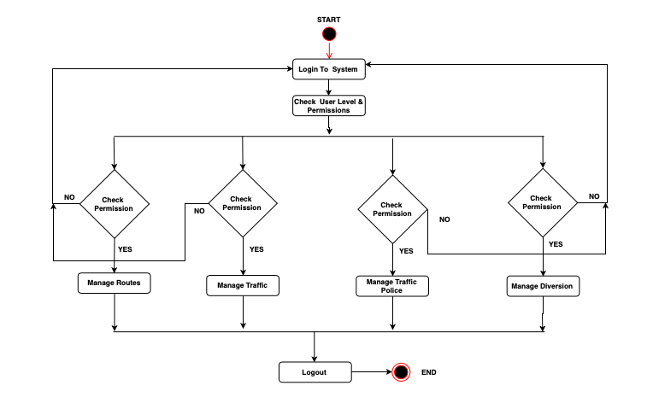

Figure 5. 1: Traffic Management System Activity Diagram

The above figure represents the UML activity diagram of traffic management system. The diagram shows the flow between the activity of routes, traffic, traffic police and diversions. Route activity, traffic activity, traffic police activity, diversion activity is the main activity that are involved in the above UML activity diagram.

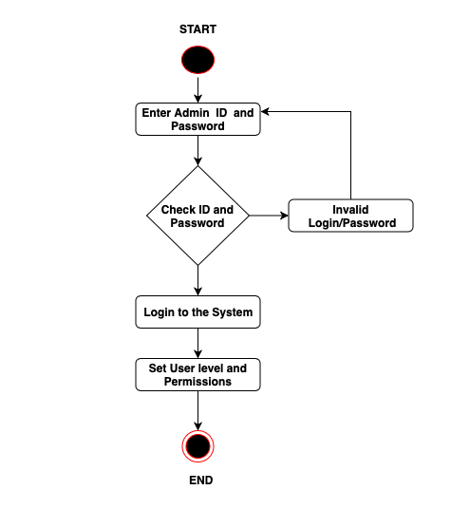

Figure 5. 2: Login Activity Diagram

The above figure represents the login activity diagram of the traffic management system. The above diagram shows how the login page works. The above diagram shows the flow of login activity. As you can see in the diagram, the admin login in the system using the username and password. When the admin is logged into the system than he would be able to manage the traffic routes, traffic diversions and traffic polices. Admin and other users cannot access the functionality of the system without verifying their identity by providing the correct username and password.

## Use Case Diagram

Use Cases diagram is graphical deception of the interaction among the elements of the system. It defines what a proposed system should do from a user’s point of view. Mainly the use case diagram captures the system functional requirements. It describes the external view of the system and its interactions with the outside world.

In this diagram the outside world is represented by actors and the actors are Admin, System User, Traffic police and users. These actors perform variable use cases among them are traffic management, route management, traffic police management and Diversion management.

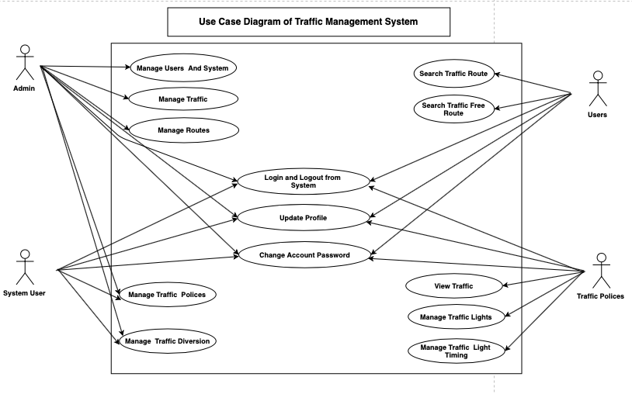

Figure 5. 3: Use Case Diagram of the System

The above figure shows the relationship between and among the actors and the use cases of the system:

* **Admin:** Management of users and system, traffic management, route management, traffic police management, management of traffic diversions are the use cases of the admin.
* **System User:** Manage traffic police, manage traffic, manage routes, manage traffic diversions are the use case of the system user.
* **Users:** Search traffic routes, search traffic free directions are the use cases of users
* **Traffic police:** Manage traffic signals, manage traffic lights timing, viewing traffics are the use case of the traffic police officer.

## Sequence Diagram

The interaction between objects in a single use case is called sequence diagram. The below diagram represents the login sequence of the system.

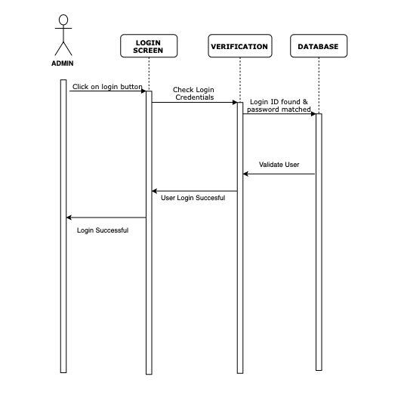

Figure 5. 4: Login Sequence Diagram

The above diagram shows the admin login to the page with username and password. The admin should provide correct credentials in order to login to the system. When the admin login to the system than he would be able to access the system functionalities such as viewing traffic, managing traffic, managing routes, managing traffic diversions and so on. The diagram shows the login sequence of the system.

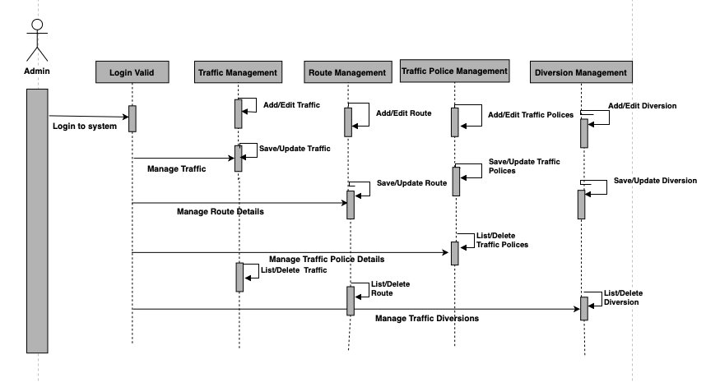

Figure 5. 5: Sequence Diagram of the System

This is the sequence diagram of the whole system. It shows the interactions between the objects: traffic, traffic police, diversions and routes.

## System Class Diagram

The system class diagram describes the structure of the system classes, attributes of the class, methods and the relationship between the objects. The main classes of the traffic management system are:

* **Route Class:** Manages all the route operations
* **Traffic Class:** Manages all the traffic operations
* **Diversion Class:** Manages all the diversion operation
* **Traffic police Class:** Manages all the traffic police operations
* **User Class:** Uses all the users operations

Classes and their Attribute of the traffic management system:

* **Route Attributes:** route_id, route_name, route_type, route_information, route_length
* **Traffic Police Attributes:** traffic_police_id, traffic_police_name, traffic_police_description, traffic_police_username, traffic_police_password
* **Traffic Attributes:** traffic_id, traffic_name, traffic_description, traffic_type, traffic_time
* **Diversion Attributes:** diversion_id, diversion_type, diversion_description, diversion_name
* Users Attribute: name, address, phone number, username, password

Classes and their Methods of the traffic management system:

* **Route Methods:** addRoutes(), editRoutes(), deleteRoutes(), updateRoutes(), searchRoutes(), displayRoutes()
* **Traffic Police Methods:** addTrafficPolice(), deleteTrafficPolice(), editTrafficPolice(), searchTrafficPolice(), displayTrafficPolice()
* **Traffic Methods:** addTraffic(), editTraffic(), deleteTraffic(), searchTraffic()
* **Diversion Methods:** addDiversion(), editDiversion(), deleteDiversion(), searchDiversion(), displayDiversions()
* **Users Methods:** addEmergencyRequest(),viewRoutes(), viewDiversions(), viewTraffic()

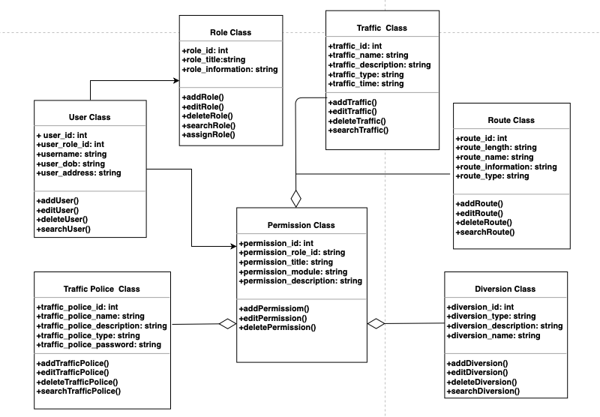

Figure 5. 6: Class Diagram of the System

## Entity Relationship Diagram (ERD)

The below entity relationship diagram shows the model of traffic management system entities. It is very important to have an entity relationship diagram to make a good database design. There are basically three elements in an entity relationship diagram. Entity is nothing but a thing to store information. An entity can be place, person, event or thing. The other element is attribute. Attributes are the for an entity. The other element is relationship. Relationship describe the relation between the entities.

Traffic Management System Entities and attribute:

* **Route Entity:** route_id, route_name, route_type, route_information, route_length are the attributes of traffic
* **Traffic Police Entity:** traffic_police_id, traffic_police_name, traffic_police_description, traffic_police_type, traffic_police_password are the attributes of traffic police
* **Traffic Entity:** traffic_id, traffic_name, traffic_description, traffic_type, traffic_time are the attributes of traffic
* **Diversion Entity:** diversion_id, diversion_type, diversion_description, diversion_name are the attributes of diversion

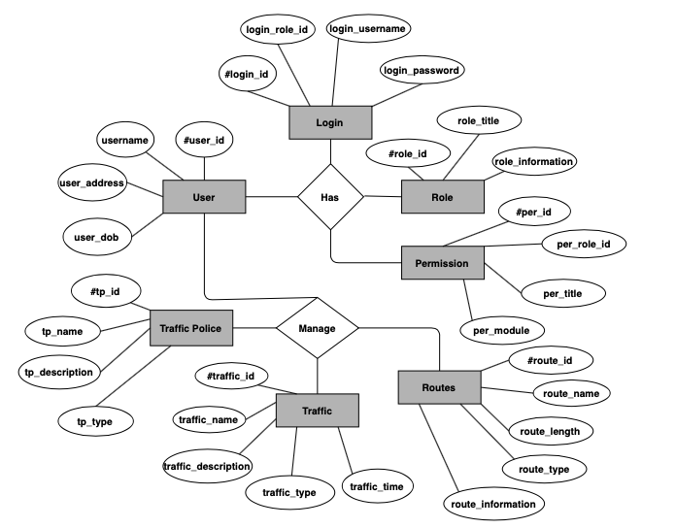

Figure 5. 7: ER-Diagram of the System

The traffic police details are stored in the traffic police table respective with all tables. Each table contains primary key. The table diversion is related with traffic, routes table with foreign key. One to one relation and many to one relationship can be seen between traffic polices, traffic, diversion.

# System Interface Design

## Draft Interface Designs

## Wireframes

The main purpose of wireframe is to arrange the elements so that the user can accomplish a goal of his design. In this case the user created the wireframe of traffic management system for the purpose of arranging the elements. In wireframes there is no use of color graphics since it main focuses on functionality and behavior of the system.

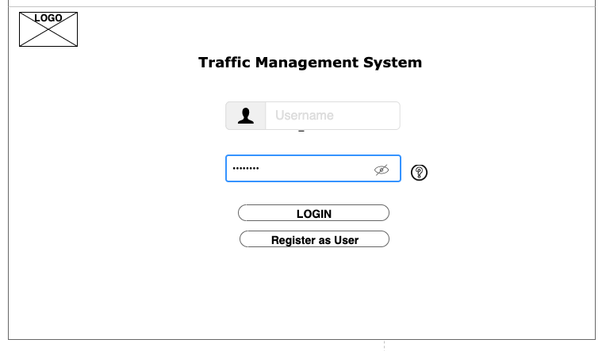

Figure 6. 1: Login portal of the system

This is the login portal for all the user to login such as users, admin, system user and traffic polices. The login through the same portal and then redirected according to their user level.

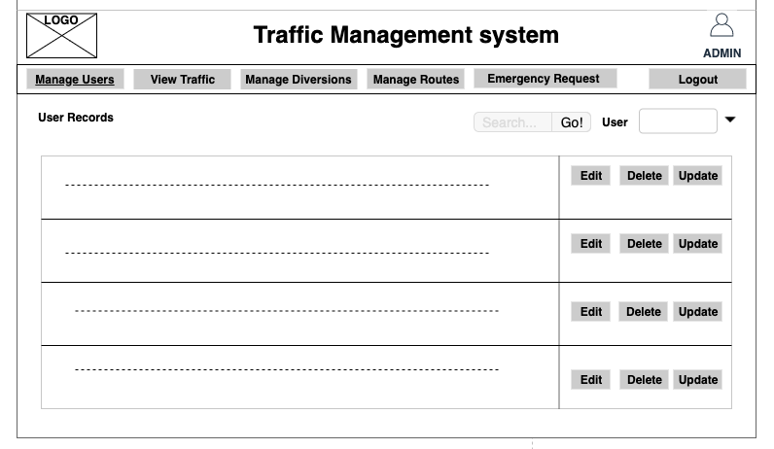

Figure 6. 2: Admin Wireframe

This is the homepage of the admin of the traffic management system. From here the admin can manage the system. He can manage users, traffic, traffic police, diversion, route and emergency request such by add, edit delete and update operations.

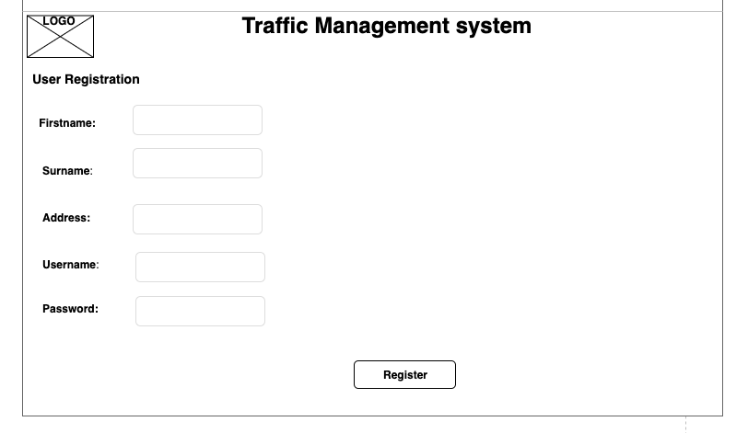

Figure 6. 3: Wireframe of User registration form

The above figure is of user registration form. The users are registered by fulfilling the form and later confirmed by the system user and admin. After confirming the form then the user is added in the system.

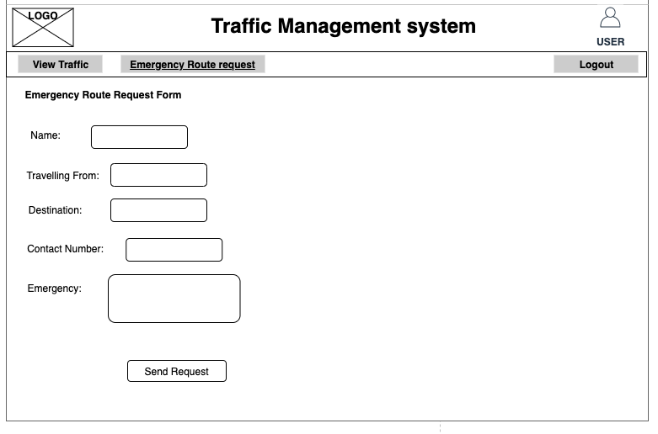

Figure 6. 4: Wireframe of emergency request form

The above figure shows the wireframe of the emergency request form. When there is an emergency for ambulance and citizens then the people would be able to send the request firm to the management team. The team confirms if there is emergency or not then provides traffic free route and assistance.

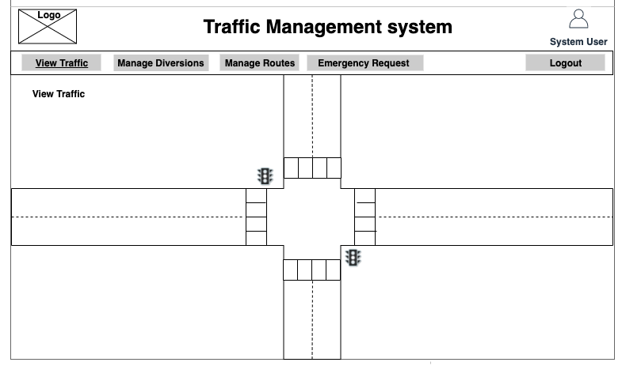

Figure 6. 5: Wireframe of System User Viewing live traffic conditions

The above figure shows the system user viewing the live traffic conditions through a simulation. The admin, traffic police and system user would be able to control traffic signals and view them.

## System Screen Mock-ups

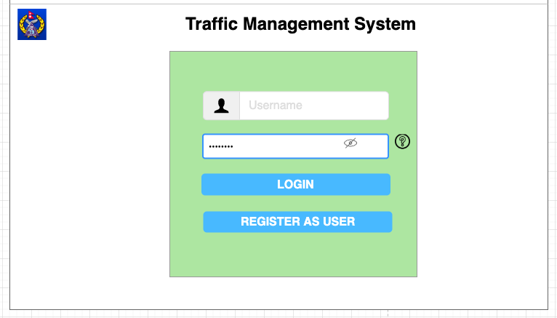

Figure 6. 6: Login Mock-up

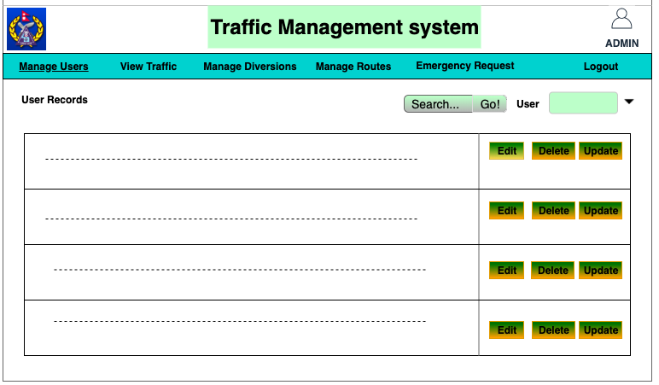

Figure 6. 7: Admin Mockup

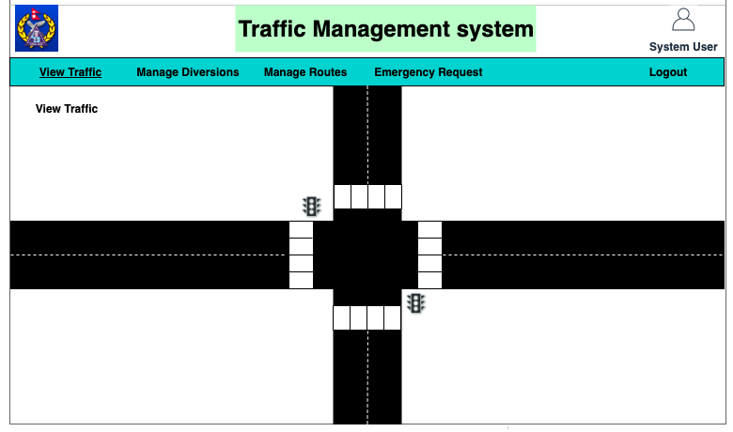

Figure 6. 8: System User Mockup

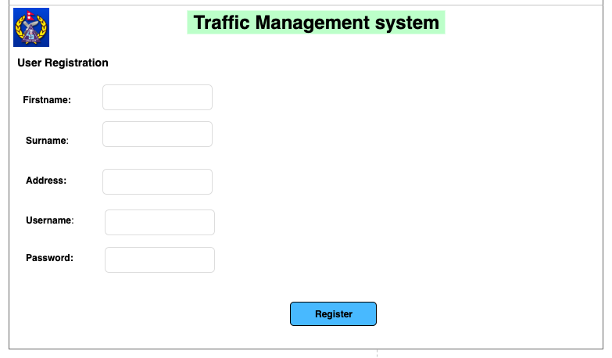

Figure 6. 9: User Registration Mockup

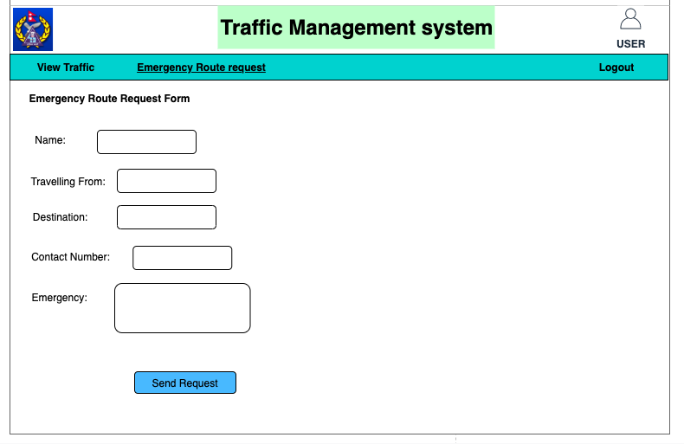

Figure 6. 10: User Mockup

# 

## Heuristic Evaluation

The heuristic evaluation is basically a usability inspection method. This method is used for inspecting software systems to identify the usability problems in the user interface. Basically, it identifies the strength and weakness of the user interface of the software system.

The following table shows the heuristic evaluation of the software UI. The highest level of conformity is denoted by 5 whereas the lowest conformity is denoted by 1.

|  |  |  |  |
| --- | --- | --- | --- |
| **Usability Criteria**  **Appropriate use of:** | **Conformity Level**  **(1-5)** | **Evidence of the software system** | **Comments/Issues** |
| **Metaphors** | 4 | Icons and images have been used in panels and buttons in the software. | Use of icons and images have resulted in great system software. |
| **Consistency and Stability** | 3 | The design and UI of the software system is consistent and stable. | Consistency and stability help users to use the system functionality without any problems. |
| **Emergency Request Message** | 3 | The emergency request for traffic information has been created and is useful for users in emergency cases. | The main drawback is the communication between the user and system user is not very useful. Message Box would be preferable. |
| **Text Font and Size** | 4 | The text font and size are suitable for all the users. Users can easily perform on the software. | Other attractive fonts can be discovered. |
| **Color** | 3 | The color use in the system is user friendly and simple. People with color blindness does not have any problem with the software color. | To make the system user friendly for all users, more attractive colors cannot be used properly. |
| **Design Model** | 4 | The design of the system software is excellent. Users can navigate from one panel to another without any problem. | The model of the system is good. |

Table 6. 1: Heuristic Evaluation

# System Build and Technical Notes

After the completion of the requirements engineering, specification, and system analysis and design stage the implementation of the software system is the main heart of the system. All the necessary tools and resources were available for building the Traffic Management System. The build of the project was implemented after all the information and resources were available.

Implementation environment, hardware/software requirements, tools and techniques used and implementation code for major functionalities are discussed. All the codes are properly maintained and there is less redundancy of files.

## System Build Environment

The Environment for the development of the project includes the hardware and software requirements. These hardware and software requirements are used for developing the software system without any problems. The following table shows the hardware and software requirements to build the system.

|  |  |
| --- | --- |
| **Software Environment** | **Hardware Environment** |
| macOs Catalina version 10.15 | 1.6 GHz Dual-Core Intel Core i5 |
| Java Eclipse 4.7.3a | 4 GB 1600 MHz DDR3 |
| Graphics | Intel HD Graphics 6000 1536 MB |

Table 7. 1: Software Build Environment

## Code and Folder Structure

In the implementation of the software system, all the code is divided on different parts such as routes, diversions, emergency requests, users, admins, traffic police. Basically, MVC framework is followed for the development of the software system. The routes management consider adding new routes, editing routes, deleting routes and viewing routes. Similarly, the diversion considers adding, editing, deleting, and viewing new diversions. The user can request for emergency clearance of traffic by sending a request to the administrator and traffic police. The admin management considers all the functionality of the system whereas the traffic police management considers some exception of the admin functionality.

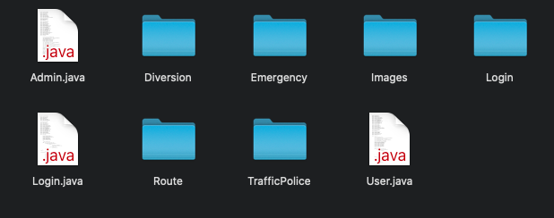

Figure 7. 1: Folder Structure

The above folder shows the code and folder structure of the traffic management system. As you can see in the figures, all the codes for functionality are separated in different folders. The Login.java file is used for logging into the administration, traffic police, and user’s area. The admin.java file contains all the functionality and features of the administrator and traffic police. Similarly, the user.java file is used for the functionality and features of the user area. The image folder contains all the necessary images and icons that are used for building the software system.

## Features and Functionality Implementation

In this section, all the major features and functionality of the software implementation is discussed. Java implementation is done on all the features and functionality of the software system.

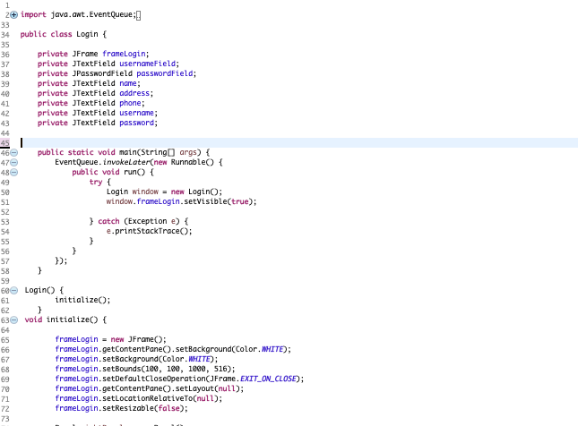

Figure 7. 2: Login Implementation

Separate frame is designed for logging into different areas of the system. The users can login from the same panel into different areas of the software system. The user has to provide correct username and password in order to login into the software system.

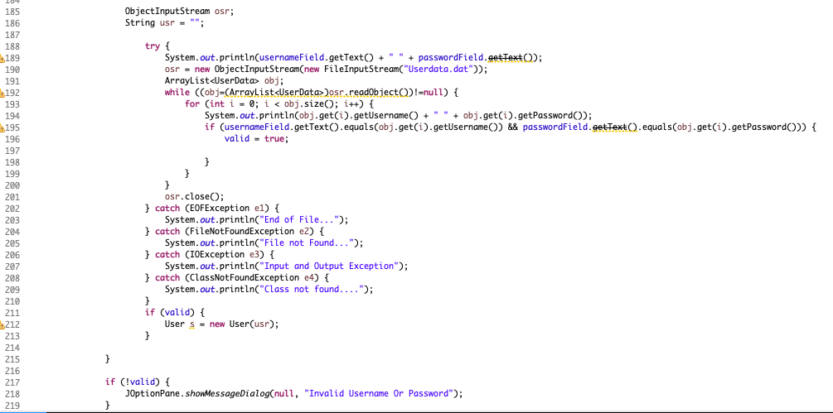

Figure 7. 3: Check Username and Password

This code checks the username and password provided by the users in the system. It checks whether the provided password matches the password that is saved into the database of the software system. If the password or username does not match the with the database username and password, then the systems throws error saying the username or password does not match.

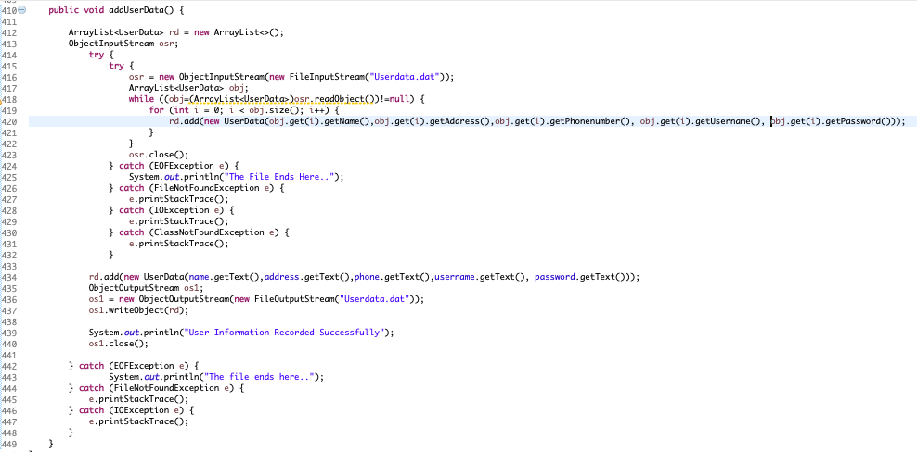

Figure 7. 4: User Signup and Add Data into file system

When a user registers into the system with the necessary credentials required to sign up into the system. The user’s data is added into the system in a file. This user data can be seen by the administrator. The user provides the desired username and password to sign up into the system.

This username and password would be used later for logging into the user area. In the user area, the user can see the traffic routes, diversions and send emergency request to the system user.

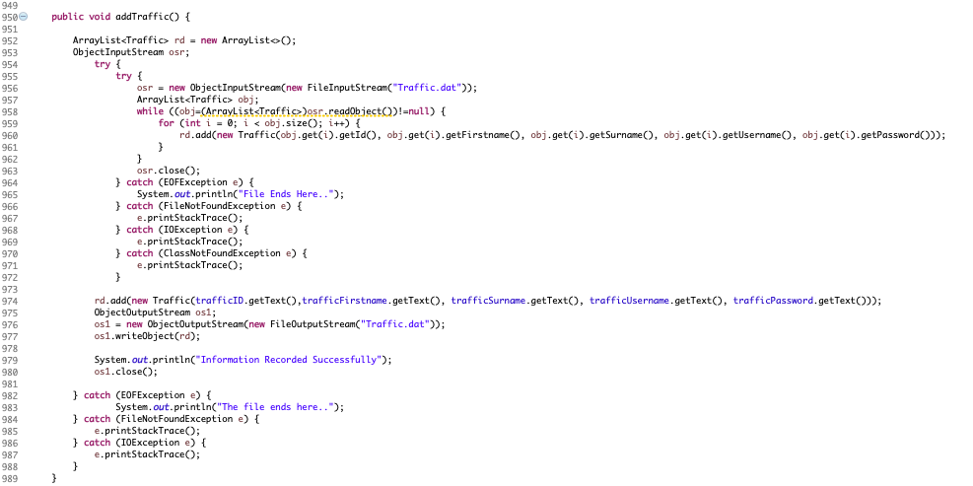

Figure 7. 5: Add Traffic Police Information

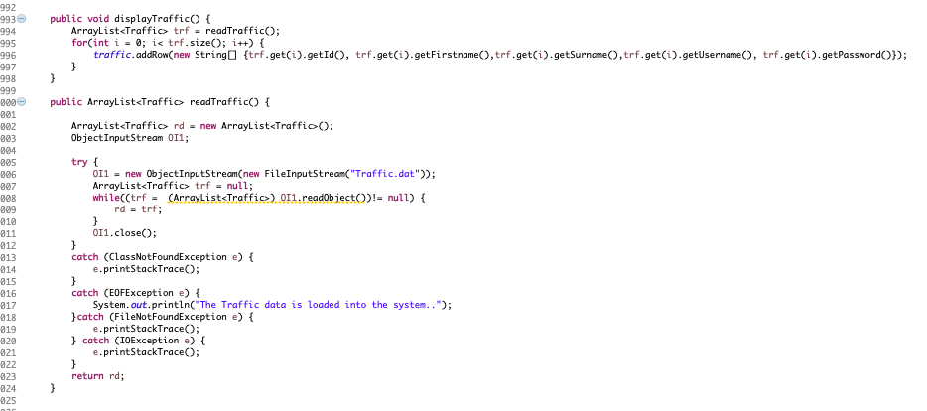

Figure 7. 6: Display Traffic Police Information

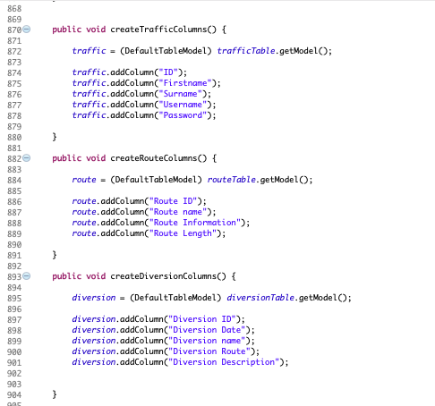

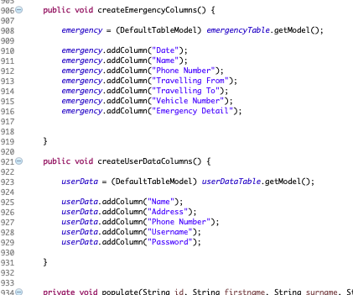

Figure 7. 7: Table Columns to display Information of traffic, routes, diversions, request and user information

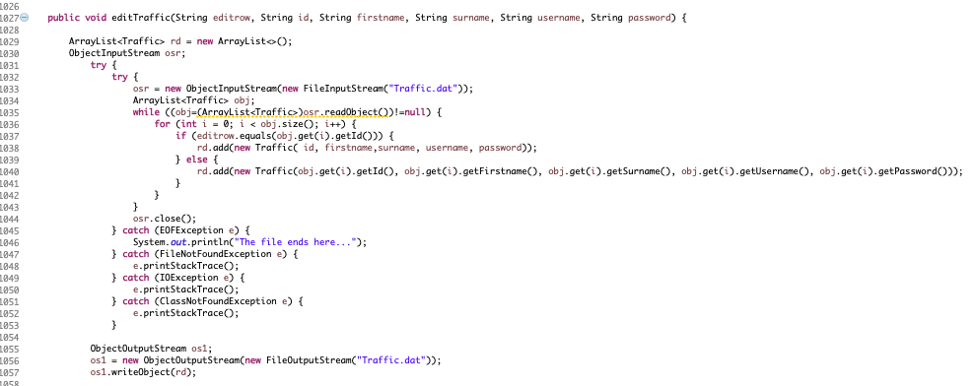

Figure 7. 8: Edit Traffic Information

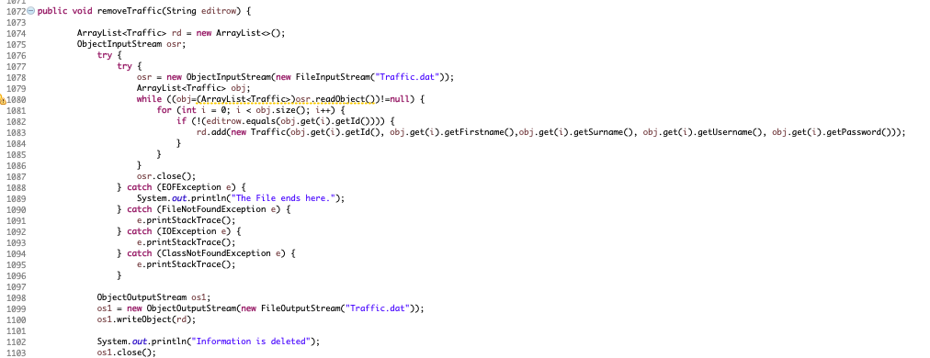

Figure 7. 9: Delete Traffic Information

The traffic information can be added, edited, deleted, and displayed by the administrator of the software system. When a traffic details is added, it is saved in the file. The added information can also be updated by editing the information. Unnecessary files can be deleted by clicking the delete buttons. When a user deletes the information, the information is no longer saved into the file system.

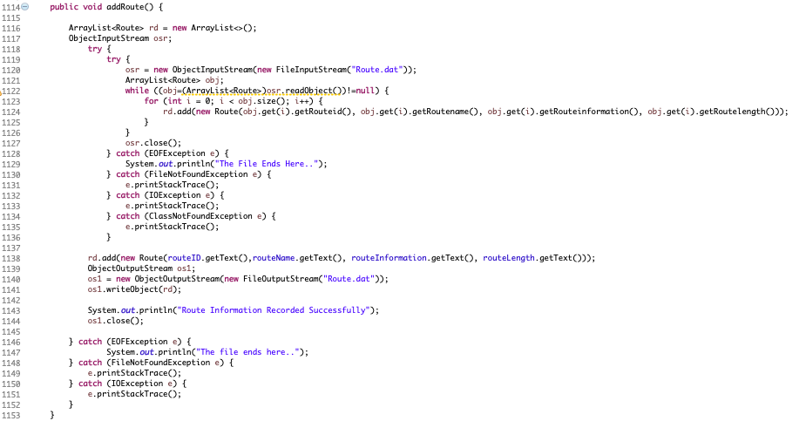

Figure 7. 10: Add Route Information

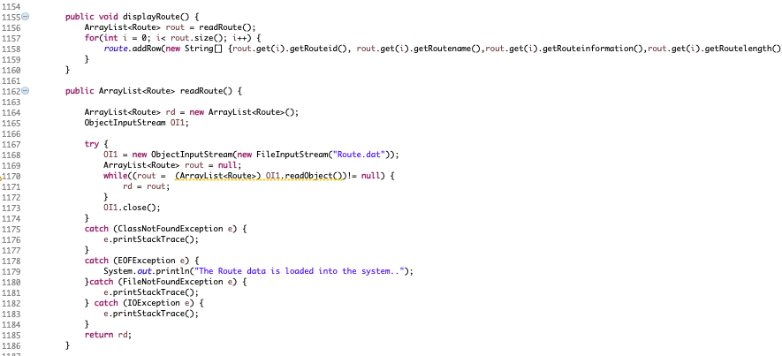

Figure 7. 11: Display Route Information

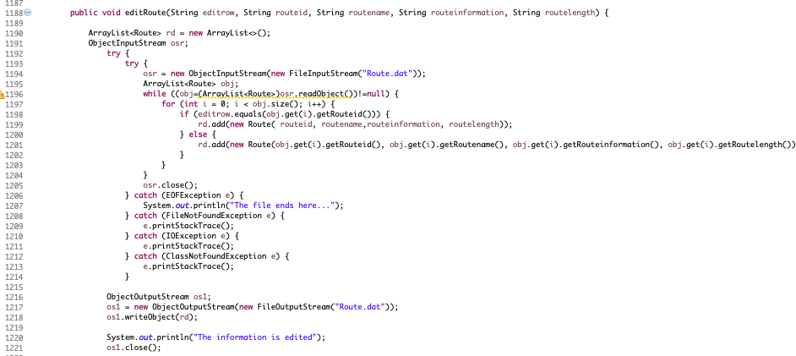

Figure 7. 12: Edit Route Information

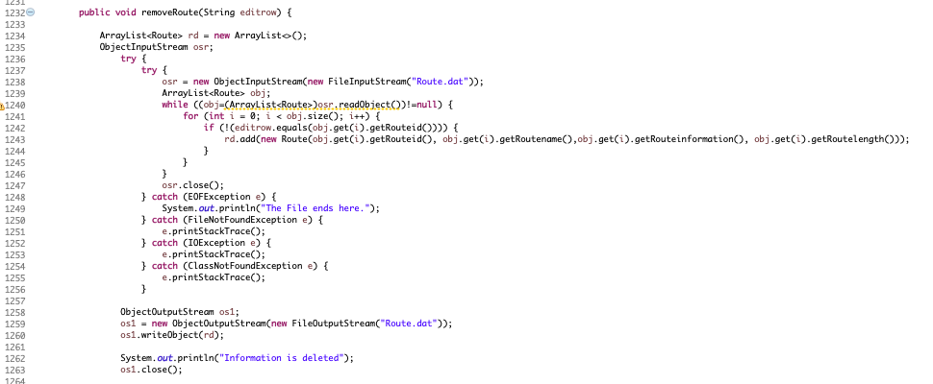

Figure 7. 13: Remove route information

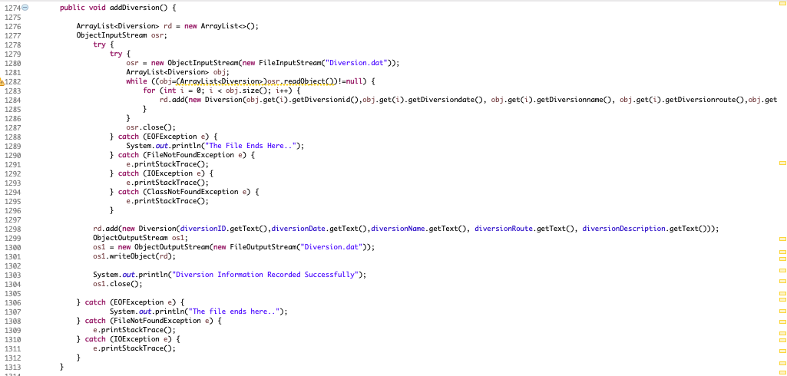

Figure 7. 14: Add Diversion Information

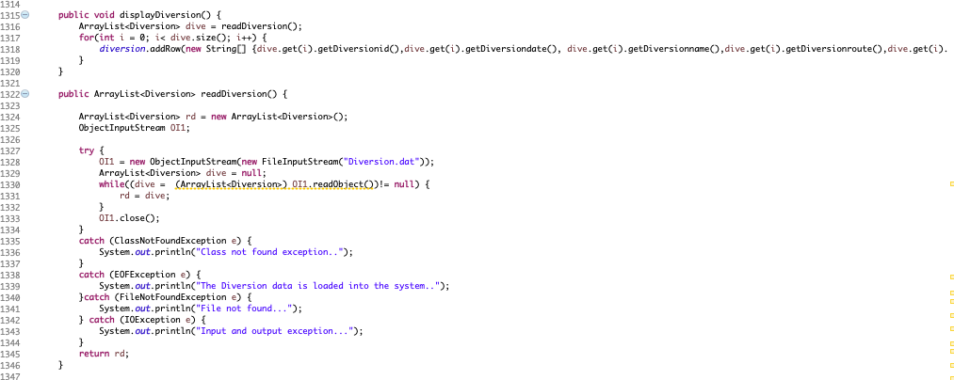

Figure 7. 15: Display Diversion Information

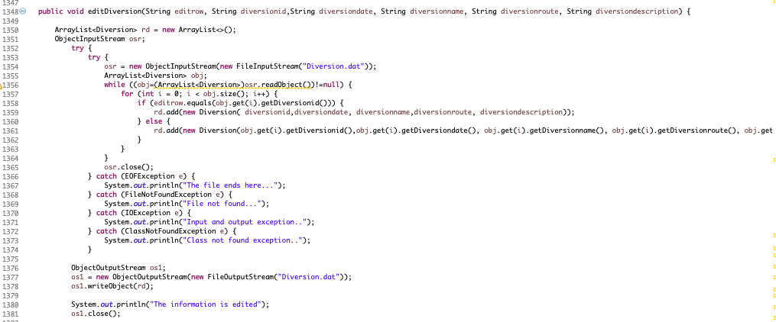

Figure 7. 16: Edit Diversion Information

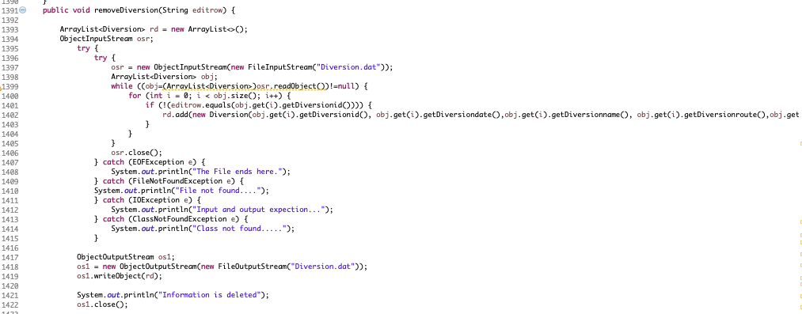

Figure 7. 17: Delete Diversion Information

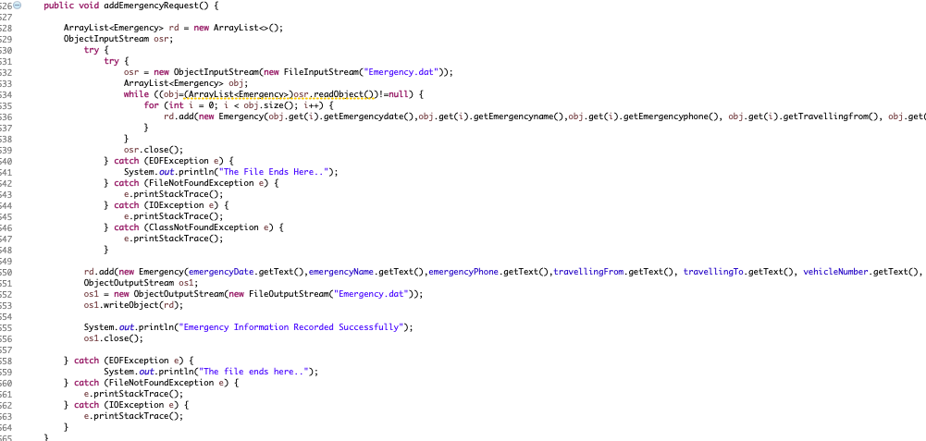

Figure 7. 18: Adding Emergency Request

This code adds the emergency requests into the software system. This emergency request is saved into the system database. This request would be displayed in the administration area and traffic police area of the software system. When a user sends the emergency request the request is immediately displayed into the system user area and traffic police area.

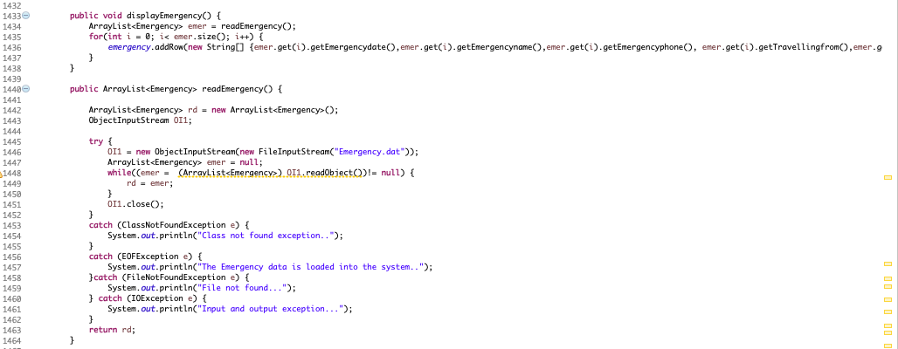

Figure 7. 19: Displaying Emergency Request in Administration area

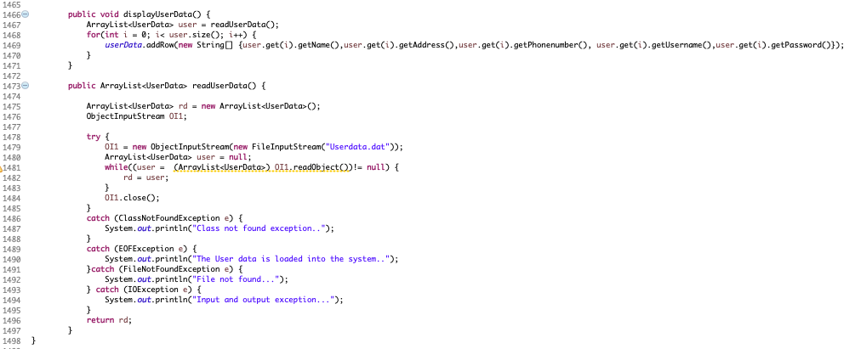

Figure 7. 20: Displaying Users Information in Admin area

All the information of traffic police, diversion, route, users, emergency request are stored in a file system. This stored information can be edited and deleted on the basis of level access given to admin, traffic police. The information is displayed in a tabular form in the software system. Admin can see the data of various things in the table. Similarly, the users can view the data of diversion and routes in the table records.

## On-going Testing Methodology

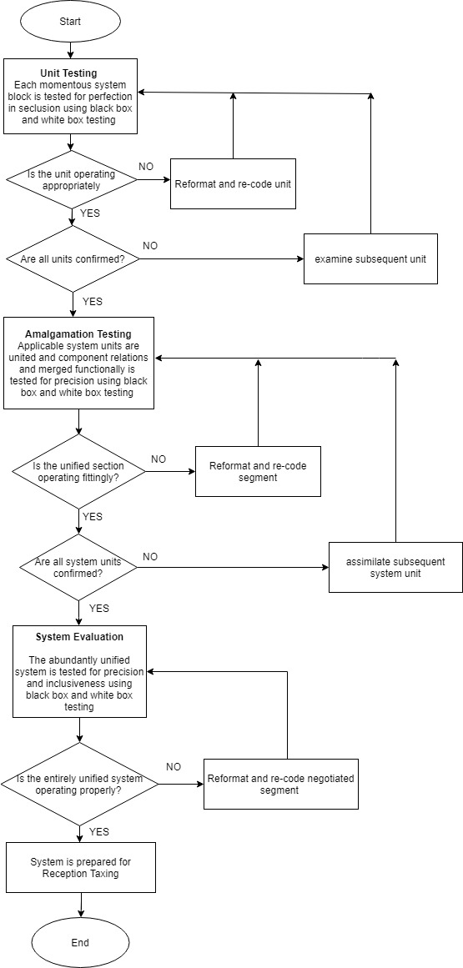

Figure 7. 21: Testing Flow Diagram

# Test Strategy

Testing is important part of the software development life cycle. Without testing a software, we cannot know its limitation and advantages. Testing is done to find out loopholes in a software and to know the limitations of the functionality and features that is implemented in the software.

## Overview of Test Strategy

**Black Box Testing**

Black Box testing method is used for the testing of the Traffic Management System. This testing method sees the system through its specification and behavior of the software system. Basically, the behavior and specification define what the system should perform and with the help of the black box testing the author tests the software. This testing method is also known as behavioral testing.

## Sample Test Results

|  |  |  |  |
| --- | --- | --- | --- |
| **Test** | **Expected Outcome** | **Actual Outcome** | **Error/ Fix** |
| **Login into the traffic management system with valid and invalid username and password as an Administrator** | | | |
| Valid Login  Username-admin  Password- admin | * Successful login to the system * Opens the dashboard of the administration | ✓ | - |
| Invalid Login (Admin)  Username- admin  Password-  12345 | * Unsuccessful login to the system * Redirect to the login page and shows password error | ✓ | - |
| **Add route information in the system** | | | |
| Add Route Details | * Add Route information successfully * Shows the information of the route added recently in the table. | ✓ | - |
| **Edit Route Details** | | | |
| Edit Route miles to 5 of id 4 | * Route Information edited successfully * Shows the edited information in the table | ✓ | - |
| **Delete Route Details of ID 4** | | | |
| Delete Route ID 4 | * The route id 4 should be deleted from the system. * Should not display the route id 4 in the table. | ✓ | - |
| **Add Traffic Police with Id 105 into the system** | | | |
| Adding traffic police with ID 105 | * The traffic police with ID 105 should be added into the system. * The traffic police with ID should be displayed in the system | ✓ | - |
| **Edit Traffic Police Information** | | | |
| Edit traffic police information  Change id number 105 name to “Babu” | * Traffic Police information should be edited * Should display the traffic name “Babu” of ID 105 | ✓ | - |
| **Delete traffic police Information** | | | |
| Delete traffic id 105 information | * The traffic id 105 should be deleted * Should not display the traffic id 105 information | ✓ | - |
| **Add Diversion Details** | | | |
| Add Diversion Details | * Should add the diversion details * Should display the details in the table. | ✓ | - |
| **Edit Diversion Details** | | | |
| Edit Diversion Detail  -Change the diversion date to 2020/08/21  Of ID 2002 | * Should update the diversion details * Should display the updated details in the table. | ✓ | - |
| **Delete Diversion Details** | | | |
| Delete Diversion Details  -Delete Diversion ID 2002 details | * The diversion details should be deleted. * The diversion id whose details is deleted should not be shown in the table. | ✓ | - |
| **Display Emergency Requests of users** | | | |
| Display emergency requests of users | * Should display the users request | ✓ | - |
| **Display Registered Users** | | | |
| Display Registered users | * Should display the registered users of the system. | ✓ | - |
| **Register as a user in the system** | | | |
| Register as a user | * The system should register the user | ✓ | - |
| **Login as a user** | | | |
| Login with username and password of user | * Should enter the system * Show Diversion, Routes and emergency request form | ✓ | - |
| **Display Diversions** | | | |
| Display Diversions Details | * Should display the diversion details | ✓ | - |
| **Display Routes** | | | |
| Display Routes | * Should Display the routes | ✓ | - |
| **Logout from the system** | | | |
| Logout | * Should logout from the system * Should be back to the login page. | ✓ | - |

Table 8. 1: Black Box Testing

# System Evaluation

System evaluation is used for assessing the performance of the software system. It is necessary to evaluate the software system to find out how it is going to perform in the real-life world or market situations. There are various factors for evaluating the software system. The main factor are the design and functionalities of a software system.

## Usability Evaluation

The main aim of usability evaluation is to take feedback from user about the design and functionalities of the software system i.e. The Traffic Management System. It is important to evaluate the software before going into the market conditions. It is also important to evaluate long term use of the software system. All the testing, requirement of the software is completed by the author except the traffic view functionality which could not be implemented due to some difficulties.

For the evaluation of the software system, the author takes the help of fellow colleges. The author gathered 5 colleges and asked them to use the system. After using the system, college feedback about the design, performance, functionalities were taken into considerations. There is no current traffic management system in our country. All the work is done by the traffic police. The author colleges like the login design of the system. The author colleges find the system user friendly and easy to use. They were able to manage the traffic police, diversions, routes, emergency requests, and user information’s. The things that they didn’t like about the system were taken into consideration and will be improve further in the future. The problems to be solved in the future are automatic generation of traffic routes and diversions if there is any case of road accident and immediate passage for the emergency services. Further, the emergency request can be improved in the future and it can be change into a chat box to chat with the system user if any emergency case arrive. They also like to see the live view of traffic conditions of different part of the country. All this information gathered from the colleges will be taken into considerations and will be improved in the future.

Other than that, the system is reliable. The system can store a bulk amount of data and the data retravel process is also fast since all the information is stored in the table. The software is secure and safe since it requires a username and password to login to the system. The software is user-friendly, people with less knowledge with software operating can use this software with no problem.

# Project Conclusion

The software system is developed by using waterfall model of software development life cycle. This model is a sequential design process that separates the development of software system into different phases. All the necessary information required to carry the development method of the software system is collected in the requirements engineering and specification phase. After collecting necessary information, the analysis and design of the software system was carried out. This includes all the designs, queries, commands, database models and so on. After the analysis and design phase, system interface design was developed before building the software. This helped in visualizing how the system should look and perform. Although, the design and build of the project is little bit different. After system interface design, the software building process started and after that the testing of the software system was carried out.

All the functionalities of the system are met except the traffic simulation functionality. The traffic simulation functionality i.e. view traffic could not be completed. Other functionalities except the traffic simulation are implemented in the software system. The functionalities that are completed are managing routes, managing diversions, managing users, and managing emergency request. The design of the system is good. Attractive fonts, colors, icons are used in the software which makes the system user friendly. The software is reliable in terms of speed, capacity, usability and reliability. The security of the system is impenetrable. Correct username and password are required in order to login to the system.

User testing should be applied in the system to find out the user error and problems. User testing should be done because the system currently focuses on the scenario where he/she knows exactly what or how to get the best use of system functionality. The user testing is one of the important factors because we can get necessary information and feedback that the software developer cannot see in his/her system. This would help them in making the system more robust and reliable.

There are some flaws in the current system that need to be fixed in the future such as when registering the user information, the user can leave the field empty and register. This should not happen in the real word which is why this flaw need to solved in the future. The identification number for the routes, diversions, users and traffic police are not automatically generated. The identification number should be unique for every record. Currently, the user puts the identification number manually. This would rise problem in the future since same identification number can be used for storing data in the system.

This software can be developed further in the future with addition of new functionalities and improving the current flaws. Some of the development functionalities that can be implemented in future are:

* Real time traffic data for system users, traffic police can be implemented in the software with the cameras in different parts of the country.
* Controlling the traffic lights from the software to make passage for emergency services
* Traffic fine system should be developed in future for the traffic polices so that they can fine vehicles that don’t abide the rules and regulations.
* Artificial intelligence implementation can be done in the future to find out the traffic accidents, rules and regulation violation and so on
* Vehicle data can be stored in the system in the future development.

# Reference

The Himalayan Times. (2019). *Traffic management turns daunting as vehicles exceed 1.1 mil mark*. [online] Available at: <https://thehimalayantimes.com/kathmandu/traffic-management-turns-daunting-as-vehicles-exceed-1-1-mil-mark/> [Accessed 23 Oct. 2019].

The Himalayan Times. (2019). Patient dies as ambulance gets stuck in traffic. [online] Available at: <https://thehimalayantimes.com/nepal/patient-dies-as-ambulance-gets-stuck-in-traffic/> [Accessed 26 Oct. 2019].

Jongwan Kim. (1997). A fuzzy logic control simulator for adaptive traffic management. Proceedings of 6th International Fuzzy Systems Conference.

2016 ,International Symposium of Transport Simulation (ISTS’16 Conference), June 23~25, 2016

2016 ,International Symposium of Transport Simulation (ISTS’16 Conference), June 23~25, 201

NLC, E. (2019). The Privacy Act, 2075 (2018) – Nepal Law Commission. [online] Lawcommission.gov.np. Available at: <http://www.lawcommission.gov.np/en/archives/20722> [Accessed 25 Oct. 2019].

Lawcommission.gov.np. (2019). Preamble – Nepal Law Commission. [online] Available at: <http://www.lawcommission.gov.np/en/archives/20347> [Accessed 25 Oct. 2019].

Lawcommission.gov.np. (2019). Motor Vehicle Tax Act, 2031 (1974) – Nepal Law Commission. [online] Available at: <http://www.lawcommission.gov.np/en/archives/13416> [Accessed 25 Oct. 2019].

NLC, E. (2019). The Act Relating to Rights of Persons with Disabilities, 2074 (2017) – Nepal Law Commission. [online] Lawcommission.gov.np. Available at: <http://www.lawcommission.gov.np/en/archives/20849> [Accessed 25 Oct. 2019].

# Appendix

## Project Plan Gantt Chart

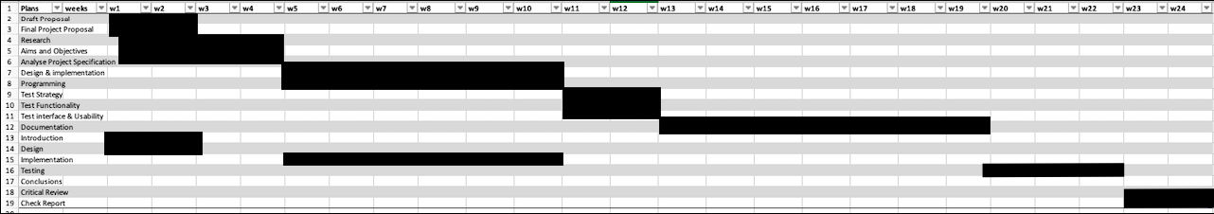

## Presentation - PowerPoint Slides











































## Final Interface Design

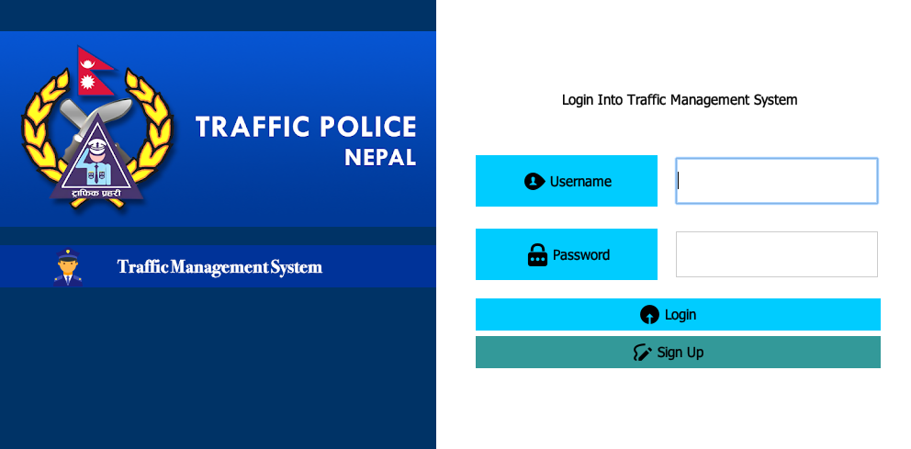

Login Panel

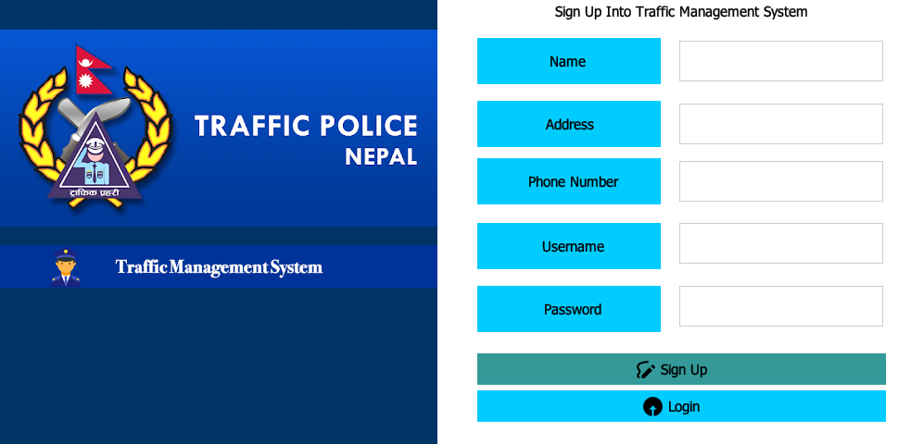

Signup Panel

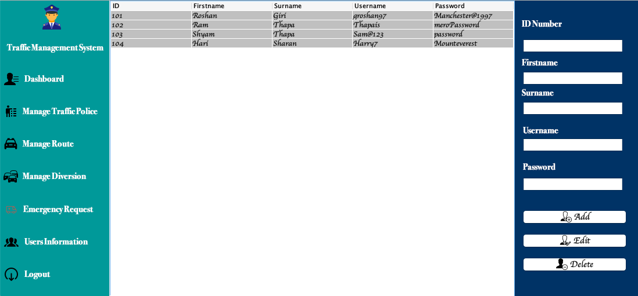

Manage Traffic Police Panel

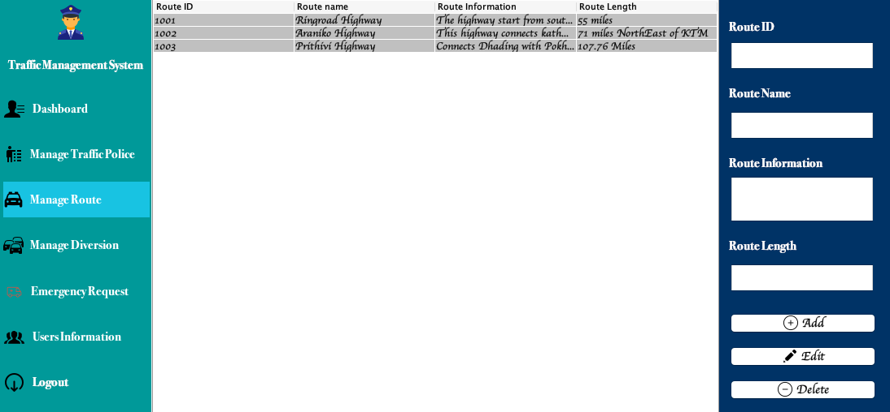

Manage Route Panel

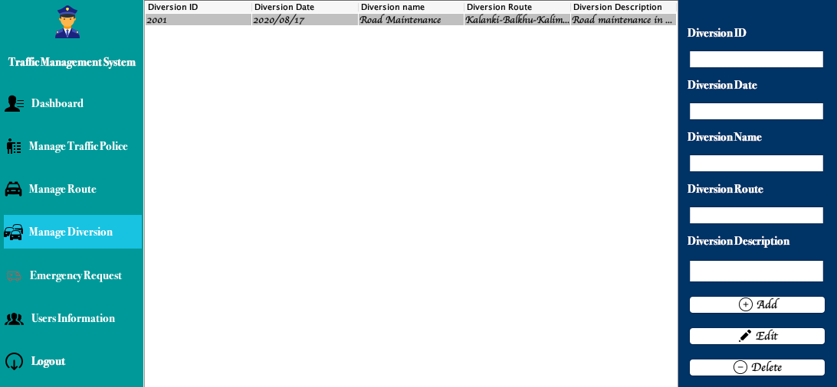

Manage Diversion Panel

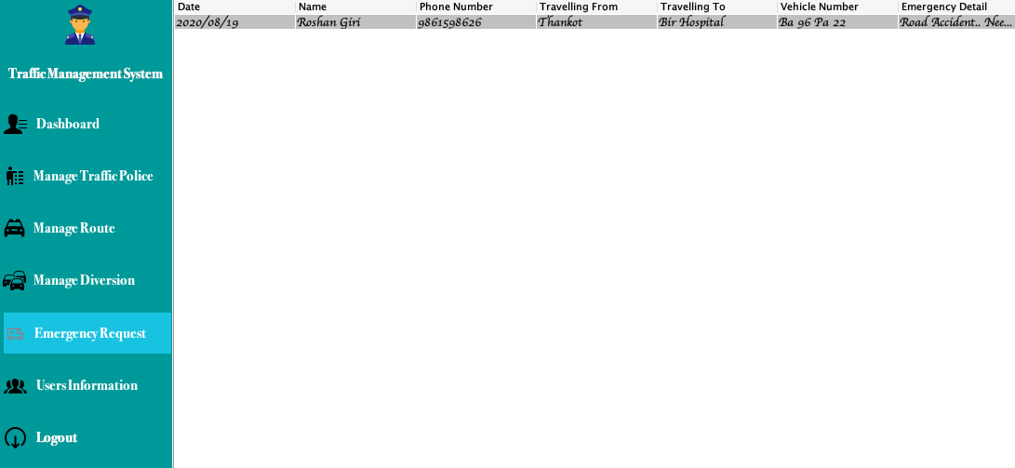

Emergency Request Panel

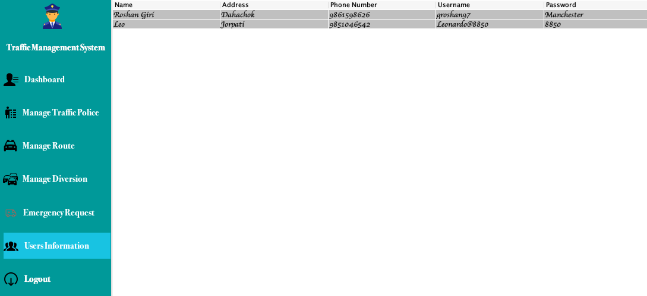

Manage User Information Panel

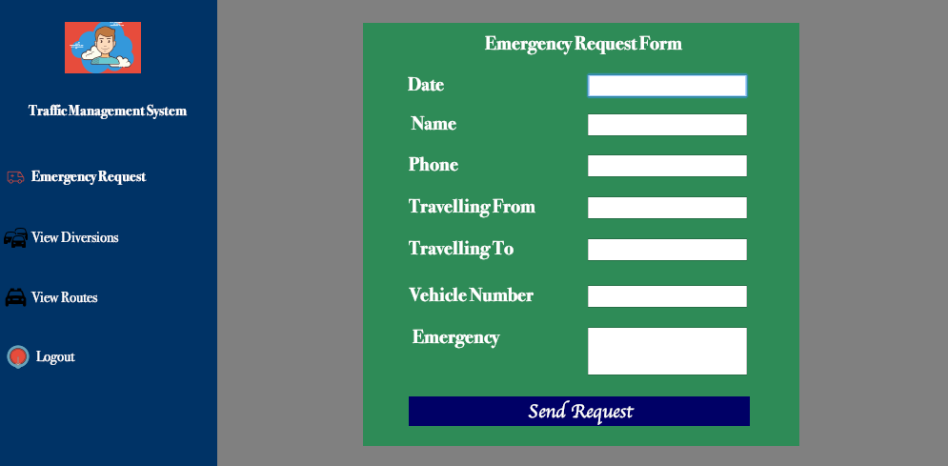

User Emergency Request Panel

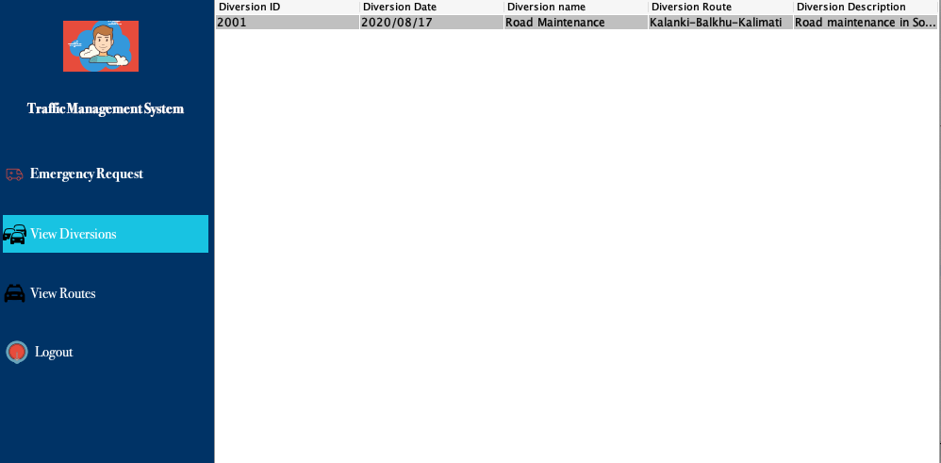

User View Diversion Panel

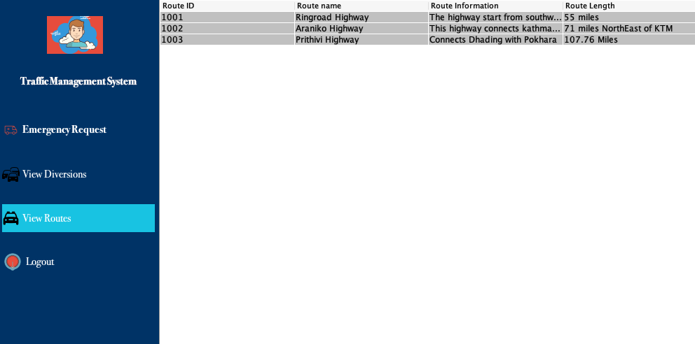

User View Routes Panel

## Supervisor Log

